Mima Omari
ST10480786
Web Development – WEDE5020
Part 1

Proposal 1: Retail Store Category
1. Organisation Overview
- Name: Define By Nature
- History: Founded in 2024, Define By Nature is an emerging South African independent streetwear and lifestyle brand focused on sustainable urban apparel.
- Mission & Vision: To inspire authentic self-expression through minimalist, eco-friendly streetwear while promoting environmental consciousness.
- Target Audience: Young adults, creatives, and urban fashion enthusiasts aged 18–32 who value modern aesthetics and sustainable clothing.
2. Website Goals and Objectives
- Primary Goals: Establish an online catalogue to build brand identity, showcase limited seasonal drops, and direct users to social channels and local pop-up stockists.
- Key Performance Indicators (KPIs): Achieve 1,500 unique monthly visitors within 3 months, maintain an average session duration above 2 minutes, and generate at least 80 contact/inquiry form submissions per month.
3. Current Website Analysis
- Strengths: Strong visual presence across social media channels (Instagram, TikTok).
- Weaknesses: Currently relies entirely on direct messaging for inquiries, leading to slow response times and an inability to showcase full product details or brand values systematically.
- Opportunities: A dedicated web platform creates a central digital hub, improves credibility, and enables organized product display.
4. Proposed Website Features and Functionality
- Pages: Home, Lookbook/Catalogue, About Us, and Contact.
- Key Features: High-resolution product showcase grid, interactive size guide modal, responsive hamburger menu, and a validated contact inquiry form.
5. Design and User Experience (UX)
- Aesthetic & Palette: Minimalist, urban industrial feel. Primary palette: Jet Black (#111111), Off-White (#F4F4F0), and Earth Olive (#4F5D2F).
- Typography: Bold sans-serif display headers (Montserrat / Oswald) paired with clean readable body text (Inter / Aptos).
- UX Considerations: Mobile-first layout, high-contrast readability, intuitive sticky navigation bar, and fast-loading image carousels.
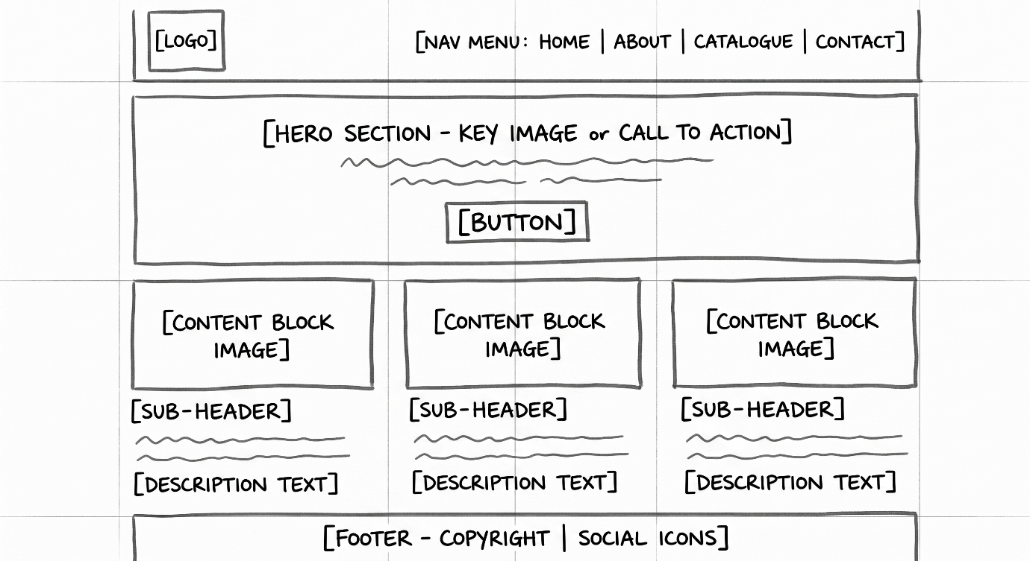
Figure 1 Home Page Low-Fidelity Wireframe
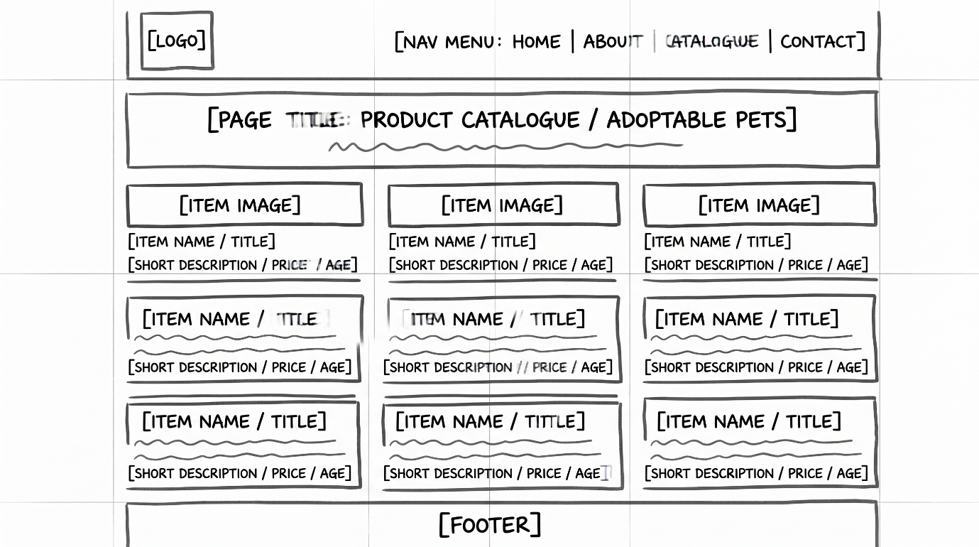
Figure 2 Products Wireframe

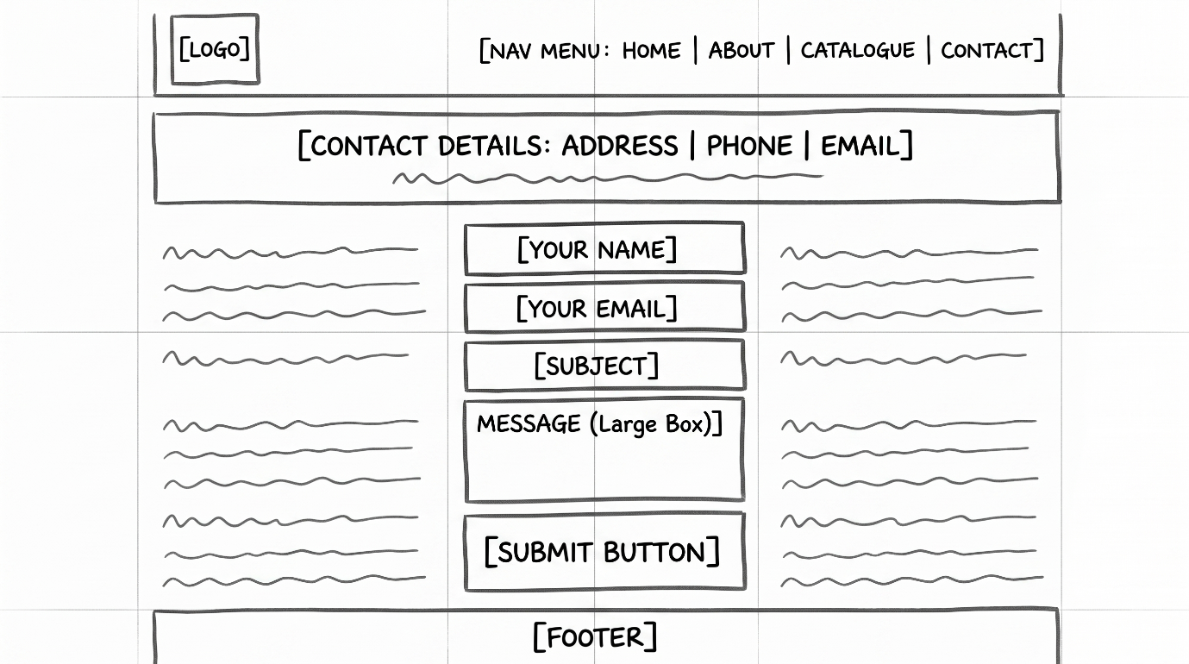
Figure 3 Contacts Page Wireframe

6. Technical Requirements
- Tech Stack: HTML5 (semantic structure), CSS3 (Flexbox/Grid and responsive media queries), and lightweight vanilla JavaScript for interactive UI elements.
- Domain & Hosting: Custom domain (.co.za or .com) hosted via GitHub Pages (initial phase) or Netlify with SSL certification.
7. Timeline and Milestones
- Milestone 1 (Part 1): Proposal approval, wireframing, and basic semantic HTML structure setup.
- Milestone 2 (Part 2): CSS styling, responsive layout implementation, and interactive visual components.
- Milestone 3 (Part 3): JavaScript functionality, cross-browser testing, SEO optimization, and final deployment.
8. Budget Estimate
- Domain Name (.co.za): R150 / year
- Hosting (Netlify / Free Tier / Cloud): R0 – R120 / month
- Development & Asset Tooling: R0 (Utilising open-source tools and student licences)
- Estimated Annual Maintenance: R1,500 – R2,500
9. References
- W3C (2023). HTML5 Semantic Elements Guide. Available at: https://www.w3.org/TR/html52/ (Accessed: 14 August 2026).
- Google Fonts (2026). Montserrat & Inter Typeface Pairings. Available at: https://fonts.google.com (Accessed: 14 August 2026).

Proposal 2: Non-Profit Organisation (NPO) Category
1. Organisation Overview
- Name: Haven Paws Animal Rescue
- History: Established in 2019 in Cape Town, Haven Paws is a community-run non-profit animal shelter dedicated to rescuing, rehabilitating, and rehoming abandoned domestic animals.
- Mission & Vision: To create a compassionate society where every companion animal receives safety and care, with a long-term vision of ending animal homelessness.
- Target Audience: Local pet adopters, animal welfare advocates, prospective volunteers, and community donors aged 20–60.
2. Website Goals and Objectives
- Primary Goals: Increase animal adoption applications, simplify volunteer registrations, and provide a clear avenue for community donations and sponsorship.
- Key Performance Indicators (KPIs): Increase monthly adoption application forms by 35%, recruit 20 active monthly volunteers, and grow organic search impressions by 50% in 6 months.
3. Current Website Analysis
- Strengths: Active community engagement on Facebook with consistent local support.
- Weaknesses: No structured database or gallery for adoptable pets; outdated contact methods cause adoption backlogs.
- Opportunities: A clean website streamlines the adoption application pipeline and categorises adoptable animals clearly.
4. Proposed Website Features and Functionality
- Pages: Home, Adoptable Pets Gallery, How to Help (Volunteering & Donations), and Contact/Directions.
- Key Features: Filterable pet profile cards (dog/cat/age), interactive adoption inquiry form, Google Maps integration for shelter visits, and FAQ accordion.
5. Design and User Experience (UX)
- Aesthetic & Palette: Warm, approachable, and trustworthy. Primary palette: Soft Teal (#2A9D8F), Warm Sand (#F4A261), Slate Grey (#264653), and Clean White (#FFFFFF).
- Typography: Friendly rounded headers (Poppins or Nunito) with a legible sans-serif for content descriptions (Aptos or Open Sans).
- UX Considerations: High accessibility (WCAG AA compliance), large accessible call-to-action buttons for donation/adoption, and seamless mobile responsiveness.

Figure 4 Home Page Layout

Figure 5 Adoptable Pets Gallery Grid Layout

Figure 6 Volunteer Registration & Contact Form Layout
6. Technical Requirements
- Tech Stack: Semantic HTML5, modern CSS3 styling, and JavaScript for pet gallery filtering and form validation.
- Domain & Hosting: Registered .org.za domain, hosted on GitHub Pages or Vercel with HTTPS encryption.
7. Timeline and Milestones
- Milestone 1 (Part 1): Information architecture, low-fidelity wireframing, and base HTML template creation.
- Milestone 2 (Part 2): Complete CSS design system, responsive navigation, and accessible forms.
- Milestone 3 (Part 3): Gallery filter scripts, cross-device QA testing, performance optimisation, and final launch.
8. Budget Estimate
- Domain Name (.org.za): R120 / year
- Web Hosting (Static Hosting Tier): R0 – R80 / month
- Asset Sourcing (Unsplash / Creative Commons): R0
- Estimated Annual Maintenance: R1,200 – R1,800
9. References
- World Wide Web Consortium (2024). Web Content Accessibility Guidelines (WCAG) 2.2. Available at: https://www.w3.org/WAI/standards-guidelines/wcag/ (Accessed: 14 August 2026).
- Unsplash (2026). Creative Commons Animal Photography Collection. Available at: https://unsplash.com (Accessed: 14 August 2026).

3.1 Content Research and Sourcing Analysis
- Organisation's Online Presence & Social Media:
  - Define By Nature: Research was conducted on existing social media engagement patterns across Instagram and TikTok, noting audience interest in garment sustainability, minimalist drops, and sizing transparency.
  - Haven Paws Animal Rescue: Research evaluated community adoption announcements across local social welfare groups, highlighting bottlenecks in managing adoption inquiries and volunteer sign-ups.
- Public Domain and Creative Commons Sourcing:
  - Visual assets and high-resolution photography were sourced from Unsplash under the Creative Commons free commercial license.
  - Typography pairings were selected from Google Fonts (open-source licenses): Montserrat and Inter for Proposal 1; Poppins and Nunito for Proposal 2.
  - Structural accessibility standards were referenced directly from the W3C Web Accessibility Initiative (WCAG 2.2).
- Original Content Generation:
  - Original copy was authored for all five core pages, including brand background narratives, mission and vision statements, detailed product catalog descriptions with pricing, adoptable pet bios, custom enquiry form requirements, and multi-location contact profiles.
4. Website Structure and Planning
4.1 Sitemap
